Anexa 1
la Nota privind crearea rețelei de resurse educaționale deschise

Fisa de identificare RED

Nume/prenume autor: MIRCEA Teodora
Denumirea resursei educaționale propuse:
PLAN DE LECȚIE
Tema/scurta descriere:
Plan de lecție cu titlul “MAKING A LIVING”. Lecția se adresează elevilor din clasa a X-a, nivel B2.
Scopul materialului propus:
- didactic (de utilizat la clasă/cu elevii)
- pentru elev (de utilizat de către elevi)
- de documentare pentru cadre didactice
- altele ………………………………….
Nivel de învățământ /clasa: a X-a
Aria curriculară/disciplina: LIMBA ENGLEZĂ
Material extracurricular: fișe de lucru, imagini
Competențe vizate:
- dezvoltarea competențelor de comunicare și scriere

LESSON PLAN

Name: Teodora MIRCEA Class: 10 A
School: ‘Unirea’ High School Level: upper intermediate
Date: 19th February 2018 No. of Students: 32
Time of lesson: from 9:00 to 9:50 Textbook: Upstream upper intermediate

______________________________________________________________________________

Lesson: MAKING A LIVING
Type of lesson: revising and developing knowledge
Skills: speaking, writing
Organization: Whole Class (WhC), Individual Work (IW), Pair work (PW), Group work (GW)
Methods: conversation, explanation, interactive methods, exercises
Materials: Student’s Book, worksheets, handouts, pictures
Lesson Aims:
- to develop Ss' speaking and writing skills
- to complete a dialogue
- to role play a dialogue
- to act out a job interview
- to complete a paragraph making comparisons
- to describe and compare professions

Specific competences:
By the end of the lesson students will be able:
- to use vocabulary connected to job interviews
- to describe characteristics of various jobs
- to use the appropriate language structures for comparing and contrasting any two professions
WARM–UP
Aim:
- to create a pleasant atmosphere and relax the Ss
Procedure:
- T greets Ss, asks for absentees and asks about Ss’ mood.
- T reads some jokes in order to create a pleasant atmosphere and relax the Ss.

Interaction: T-Ss
Timing: 3 min.

ACTIVITY 1
Aims:
- to complete a dialogue
- to role play a dialogue
Procedure:
- T asks Ss to read out the words/ phrases in the list and use them to complete the gaps of a dialogue about a job interview (ex. 1)
- T plays the recording for Ss to check their answers.
- Ss work in pairs, take roles and act out the dialogue.
- T asks some pairs to act out the dialogue in front of the class.
Interaction: IW, PW, S-S
Timing: 7 min.

ACTIVITY 2
Aim:
- to act out a job interview
Procedure:
- In pairs, Ss are given job interview related dialogue tasks that involve various occupations (ex. 2)
- T explains the task and asks pairs of Ss to take roles and act out dialogues similar to the previous exercise using their own ideas and the useful language in the box. Ss write the dialogue in their notebooks.
- T asks some pairs to act out the dialogue in front of the class.
Interaction: IW, PW, S-S
Timing: 10 min.

ACTIVITY 3
Aim:
- to complete a paragraph making comparisons
Procedure:
- T asks Ss to look at the pictures and elicits which professions are shown (taxi driver and doctor) and then elicits some ways in which they are different (ex. 3)
- T asks Ss to read the paragraph and choose the correct words to complete the gaps.
- T checks Ss’ answers around the class.
Interaction: PW, S-S, Ss-T-Ss
Timing: 7 min.

ACTIVITY 4
Aim:
- to compare two professions
Procedure:
- T asks Ss to read the ideas given under the two pictures (ex. 4).
- T explains the task and ask Ss to compare and contrast the two professions shown using the ideas and appropriate linkers.
- T checks Ss’ answers around the class.
Interaction: IW, Ss-T-Ss
Timing: 10 min.

ACTIVITY 5
Aim:
- to write a paragraph making comparisons
Procedure:
- T asks pairs of Ss to choose two more jobs to compare in the same way. They prepare and write together some characteristics for both jobs. Each pair then reads their comparison with phrases from the comparison box to the class, but instead they replace the jobs with A and B. At the end the class guesses the two jobs (ex.5)
- At the end of the lesson, the very active students are rewarded, praised, while the less active ones are encouraged to get more involved in the future lessons.
Interaction: PW, S-S, Ss-T-Ss
Timing: 13 min.

WORKSHET

JOB INTERVIEW

1. a) Complete the dialogue. Use the words and phrases in the list.
- Do you have any relevant experience?
- Have a seat
- when can you start
- Thanks for coming in.
- tell me a bit about yourself

A: Hello. You must be John Brown.
B: Yes, good morning.
A: 1) ……………………………….. , John. I’m Tim Marti.
B: Nice to meet you.
A: So, 2) ……………………………….. , John.
B: Well, I’m 20 years old, I’m a university student and I want a part-time job to help with my living expenses.
A: Okay. Why should I consider you for this job?
B: Well, I’m hardworking and efficient and I work well in a team. I’m also cheerful and friendly.
A: I see. 3) ……………………………….. ?
B: Yes. Over the last two summers I worked as a waiter for a catering company at a variety of events. I have a letter of recommendation here.
A: Thank you. Should I offer you the job, 4) ……………………………….. ?
B: Right away!
A: OK. 5) ……………………………….. . I’ll be in touch.
B: Thank you very much. I hope to hear from you soon.

b) Take roles and read the dialogue aloud.
2. Your local supermarket is advertising for part-time shop assistants. In pairs use the language in the box to act out a job interview. Use the dialogue in Ex. 1 as a model.

Interviewing a person for a job | Replying
- Please, have a seat.  - Tell me about yourself.  - Why should we consider you for this job/employ you?  - Why do you want this job?/ Why do you want to work here?  - Do you have any relevant experience?  - When can you start? | - Thank you.  - I’m ………. old, ……….  - I’m (hardworking, kind, caring, sensible, etc.)  - I want to ……….  - I have worked as ……….  - Right away/ Next week.
MAKING COMPARISONS

3. Which professions can you see in the photographs? What are some of the ways in which they differ? Choose the correct words to complete the paragraph.
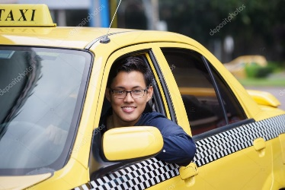
1) Both/ As doctors and taxi drivers have interesting jobs 2) but/ in spite their jobs differ in many respects. 3) Although/ Despite no special skills are required for being a taxi driver, becoming a doctor requires years of training. Both jobs require working nights and weekends. 4) However,/ Also, doctors have a safer job compared to taxi drivers who are often the victims of crime. Both jobs can be very stressful 5) but/ despite a doctor’s job is more rewarding 6) as/ on the other hand they change people’s lives for the better. 7) In addition,/ Nevertheless, doctors earn more money than taxi drivers.

4. Look at the pictures below. Use the phrases in the language box and the ideas below to compare the two professions.
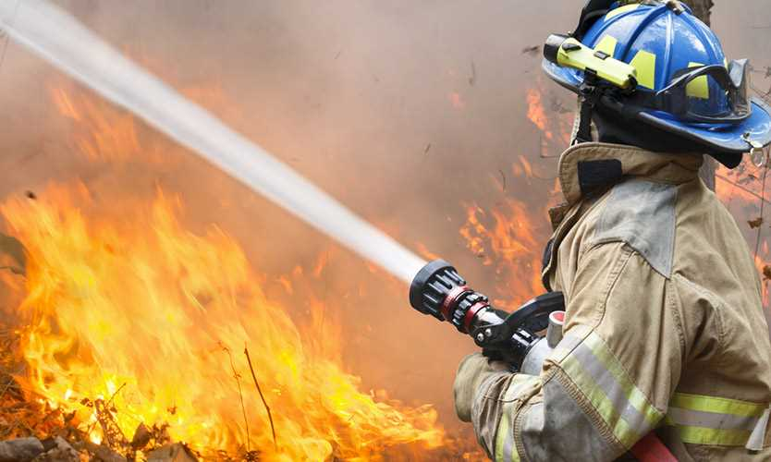

Baker  - not dangerous job  - once mastered, no new skills to learn  - happy work environment  - work long hours every day  - poorly paid | Firefighter  - hazardous, risky job  - requires constant training  - witness people getting hurt  - shift work  - financial security

Contrasting ideas
- Both ….. and …..  - Compared to  - In addition,  - Also, | - Although + clause  - Despite + -ing form/ noun  - On the other hand,  - However,
KEYS

1. a)
- Have a seat
- tell me a bit about yourself
- Do you have any relevant experience
- when can you start
- Thanks for coming in.

b) Ss work in pairs, take roles and act out the dialogue.

2. Suggested answer
A: Hello, you must be Frank Green.
B: Yes, good afternoon.
A: Please have a seat, Frank. I’m Emma Smith.
B: Pleased to meet you.
A: So, tell me about yourself, Frank.
B: I’m 23 years old, I’m studying at university and I need a job to help with living expenses.
A: What should we employ you?
B: Well, I’m reliable, enthusiastic and I work well with others.
A: Do you have any relevant experience?
B: Yes, I worked Saturdays in a clothing shop in the city centre last summer.
A: OK. If I offer you the job, when could you start?
B: Next week.
A: OK, thanks for coming in. I’ll be in touch.
B: Thank you for your time. I hope to hear from you soon!

3.

- Both
- but
- Although
- However
- but
- as
- in addition

4.
Both bakers and firefighters have interesting jobs, but their jobs differ in many ways.
To start with, a baker’s job is not as dangerous. A firefighter’s job is hazardous and risky. Although once mastered there are no new skills to be learned being a baker, working as a firefighter requires constant training. Also, a baker has a happy work environment whereas a firefighter can witness people getting hurt. In addition, a baker must work long hours every day compared to a firefighter, who does shift work. Also, a firefighter has financial security because he gets paid well. A baker, on the other hand, can be poorly paid.

